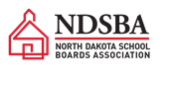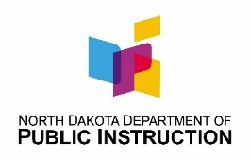**Annual Co-sponsored Informational Training for**

**School Board Members**

**July 19, 2021**

**8:30 am Registration**

**9:00 am – 4:00 pm**

**State Capitol**

**AGENDA**

8:30-9:00 Registration

9:00-9:30 Welcome

* Executive Director Alexis Baxley, ND School Boards Association (NDSBA)
* State Superintendent Kirsten Baesler, Department of Public Instruction (NDDPI)

9:30-10:15 Federal Funding COVID Update: Making an Impact

* Kirsten Baesler, State Superintendent
* Laurie Matzke, Assistant State Superintendent

10:15-10:45 2021 Legislative Impacts on Schools

* Joe Kolosky, Director, School Approval & Opportunity
* Jim Upgren, Legislative Lead and Assistant Director School Approval & Opportunity

10:45-11:00 Break

11:00-11:40 Choice Ready Graduate

* Laurie Matzke, NDDPI Assistant State Superintendent
* Ross Roemmich, Director Management Information System

11:40-12:00 Questions

12:00-12:30 Lunch – Sponsored by ND School Boards Association

12:30-1:15 K12 Student Funding Formula and School Construction

* Adam Tescher, Director NDDPI Office of School Finance & Organization

1:15-2:00 NDDPI Funded Professional Development for School Boards

* Kirsten Baesler, State Superintendent

2:00-2:15 Break

2:15-2:45 Overview of Resources on NDSBA and NDDPI Websites

* + - * + Alexis Baxley, ND School Boards Association
        + Kirsten Baesler, Department of Public Instruction

2:45 – 3:30 Q & A and Closing Remarks